Project Funding Proposal
2012 Lucerne Ave
Stockton, CA 95203

Prepared by:
Name
Entity
email@awesome.com
123.456.7890

Executive Summary
With the pending acquisition of 2012 Lucerne Ave in Stockton, CA, we are glad to present this asset to our partners as a wonderful and secure investment that has the potential to yield a good rate of return in a minimal amount of time. Located in Central Stockton, CA, this property is in a nice area of the city and in a neighborhood close to Victory Park that consistently yields high rents and has similar properties being sold as Standard Sales within 60 days on the market.

We are purchasing this property off-market for a cost of $136,000. It has an After-Repair Value of $225,000 and is in need of approximately $35,000 worth of rehab. Once rehab is complete, this home will by far exceed other homes in this market area. The job will include all quality materials, including new countertops, new flooring, fresh paint inside and outside, new windows, new appliances, central heat/air, and new lighting. Rehab will not expand the square footage of the property. This property has a close date of on or before August 31st, 2017.

Property Characteristics
Beds: 2
Baths: 1
Garage: 2 Car Detached
Living Square Footage: 953
Year Built: 1940
Listing Description: Off-market property being purchased from a wholesaler.

Projected Numbers
Purchase Price: $136,000
Closing Costs on Purchase: Approx. $3,000
Rehab Budget: $35,000
Holding Costs: Approx. $1,500
Total Project Cost: $175,500
ARV (After-Repair Value): $225,000
Total Equity: $49,500
INVESTOR PROPOSAL

Property Address: 108 Packanack Lake Rd
City: Wayne
State: NJ
Zip Code: 12123

Prepared By:
Name: sad sad
Company: sadsa
Email: abdullah.baig1998@gmail.com
Phone: 03355279329

----------------------------------------

EXECUTIVE SUMMARY

We are presenting an investment opportunity for the property located at 108 Packanack Lake Rd.

----------------------------------------

PROPERTY DETAILS

Purchase Price: 709900
After Repair Value (ARV): 851880
Rehab Budget: 83685
Holding Costs: 21297
Closing Costs: 14198

Total Project Cost: 829080
Estimated Profit: 22800

----------------------------------------

FINANCING DETAILS

Loan Amount: 21323
Interest Rate: 123312
Loan Term: 123231

Lender Name: ledgert 1

----------------------------------------

CONTRACTOR DETAILS

Contractor Name: sad sad
Contractor Email: abdullah.baig1998@gmail.com
Contractor Phone: 03355279329

----------------------------------------

TIMELINE

Start Date: 2026-04-01
End Date: 2026-05-01
Project Duration: 4 weeks (30 days)

----------------------------------------

NOTES

here is edited notes

Neighborhood Profile
The median home value in 95203 is $216,700. 95203 home values have gone up 20.9% over the past year and Zillow predicts they will rise 5.5% within the next year. The median list price per square foot in 95203 is $166, which is lower than the Stockton average of $167. The median price of homes currently listed in 95203 is $208,500.

Foreclosures will be a factor impacting home values in the next several years. In 95203 3.0 homes are foreclosed (per 10,000). This is greater than the Stockton value of 2.2 and also greater than the national value of 1.7. (www.zillow.com)

Comparative Market Analysis

No. | ADDRESS | COE | TYPE | PRICE | SQFT | BEDS | BATHS
1 | 2012 Lucerne Ave | -- | Subject | $136,000.00 | 953 | 2 | 1
2 | 1888 W Willow St | 8/16/2017 | Sold | $227,000.00 | 1052 | 2 | 1
3 | 2357 Lucerne Ave | 6/22/2017 | Sold | $220,000.00 | 1174 | 3 | 1
4 | 1853 W Harding Way | 6/9/2017 | Sold | $218,000.00 | 1208 | 2 | 1
5 | 2425 W Lucerne Ave | 6/7/2017 | Sold | $220,000.00 | 1066 | 3 | 1.5
6 | 1433 N Columbia Ave | 5/25/2017 | Sold | $209,000.00 | 1038 | 2 | 1
7 | 1711 W Flora St | 5/18/2017 | Sold | $215,000.00 | 1134 | 2 | 1

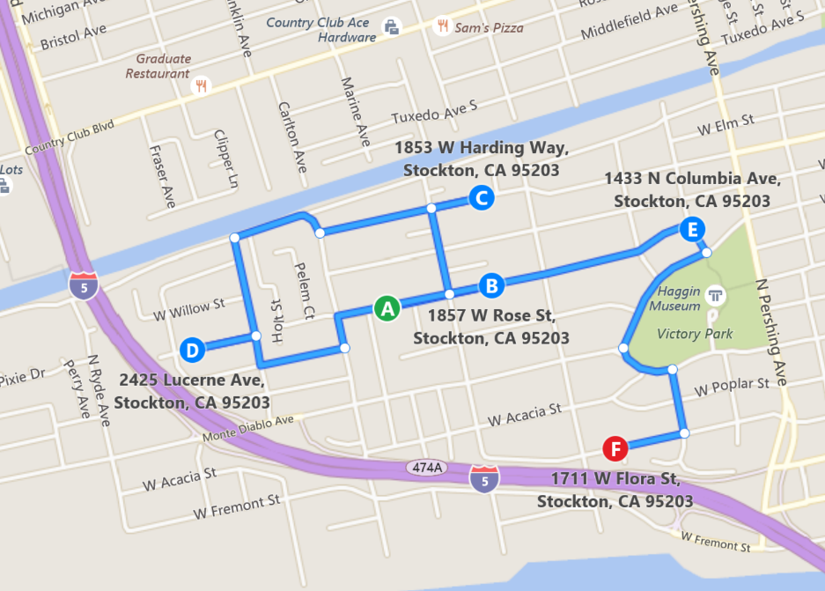
6
5
4
3
2
1

Exit Strategy
- FSBO (For Sale By Owner: A couple months after we acquire the property, we will begin marketing it on Craigslist, Zillow, and other FSBO sites. We will also begin calling local realtors and brokerages to let them know that this will be available in 30-60 days and, if they have buyers, to let them know now.
- Traditional Sale: Once rehab is complete (estimated 8-12 weeks), if we do not have an acceptable offer based on our FSBO efforts, we will have an agent list it on the MLS at 5% commission. We will also market it with flyers in the neighborhood, in local newspaper ads, and with open houses. Our strategy will be to list it at $229,900 in order to attract buyers that might qualify or that are looking for properties with a threshold of $230K. This will open the door for fast action, high competition in offers, and a higher driven purchase price for the winning bid.

Rehab Overview
This is a brief summary of all of the rehab work that will be done. The total cost for this work will be $35,000 and will include the following improvements:

- Paint (interior/exterior)
- Baseboards
- Flooring (carpet/tile/re-engineered hardwood)
- 6 panel doors
- Lighting and Electrical fixtures
- Landscaping (front yard curb appeal, backyard cleanup)
- Kitchen (new countertops, paint cabinets, new appliances, new hardware, new flooring)
- Bathroom (new toilet and flooring, tile surround, vanity)
- Drywall replacement
- Plumbing/Electrical work
- Roof work (garage)
- Dual pane windows
- Working HVAC

Additional Photos – Subject Property

